
Headsail – measurement form /page 1

1 – Measurer
Measured by ……………..……………………………………………………...……………………………………………………………………………...
Place, date …………………………………………………………………………………………………………………………………………………………

2 – Customer and boat
Customer ……….……………………………………………………………………... contact ph./e-mail ……………………………………………….
Boat type: builder ……………..………………………………… model ……………………………………………………… year …..………….........
Boat name …………………….…………………………………………………………..… sail number ……..……………………………………........
Measurement certificate (attach): IMS □ IRC □    ORC □   ORC Club □  PPJK □    other …….................................

3 – Rig details
Ri type: Sloop □    Ketch □      Catboat □ other.......................................................................................
Masthad:     3/4  □    7/8 □    9/10 □ other …………………………………………………………………………………..
Nbr. spreaders …..................................... Swept-back spreaders: YES □ NO □
Runners: YES □ NO □ Other details ………………………………...........................................

4 – Principal dimensions
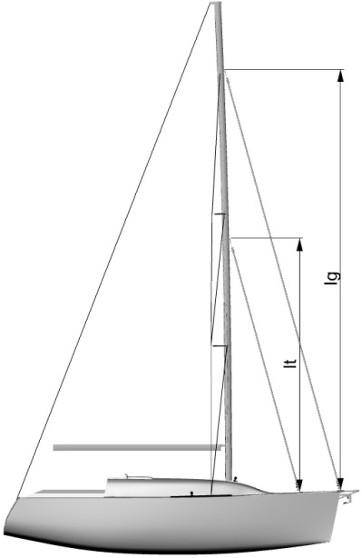
from deck (NOT DECKHOUSE!)
to forestay top attachment Ig = ………………………

from deck (NOT DECKHOUSE!)

to inner forestay top attachment It = ……………………….

from forestay base to mast J = ………………...........

from inner forestay base to mast Jt = …………………......

from forestay base to chainplates chainplates to boat centrline

S=............................................ S₁ = …………………...................

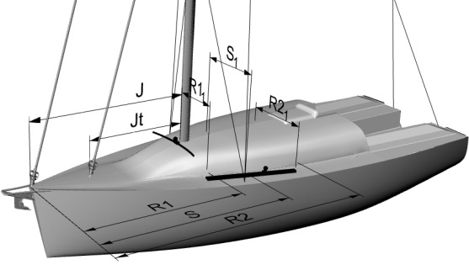
from forestay base to fwd en of genoa track R1 = ………………........
v 1.0
v 1.0

fwd end of genoa trackto boat centerline R1₁= ……………………...
v 1.0
v 1.0

from forestay baseto aft nd of genoa track R2 = ……………………...

aft end of genoa track to boat centerline R2₁ = ………………………
v 1.0
v 1.0
v 1.0
v 1.0
v 1.0
Headsail – measurement form /page 2

5 – Maximum luff and leech lengths
hoist the genoa halyard (or the furler head swivel in case of case of a furling headstay) FULLY, and measure to:
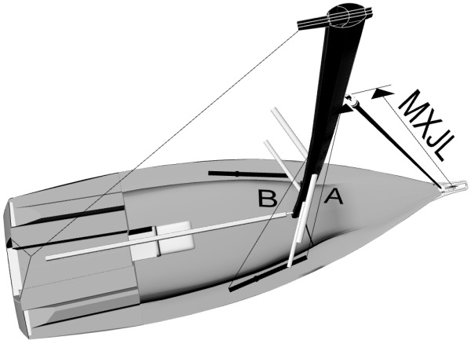
the genoa tack fittin on deck (or on the durling drum, if present) MXJL = ………………………
the genoa sheet car fully forward A = …………………………….
the genoashet car fully aft B = …………………………….

6 – Tack fitting
the racing (NON FURING!) headsail tack fitting on deck is:
hooks   □  athwartship padeye   □  longitudinal padeye   □  snahook □       other ………………..…......................

7 – Furling system
Make and model …………………………………………………………………………………………………………………………………………
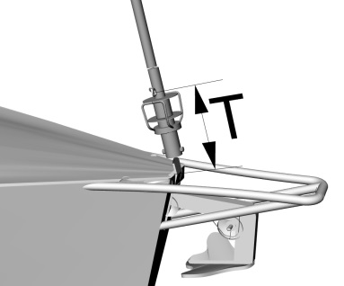

furling drum is: above deck □  below deck □ 
distance from tack fitting above the drum to deck
T = ………………………………
Furing rotation, as seen from above is: clockwise □  anticlockwise □  any □ 

8 – Racing headfoil of hanks
forestay diameter (for hanks) = ………………………………… stainless steel □     composite □ 
inner forestay diameter = …………………………………… stainless steel  □      composite □ 
Make and model (NON FURLING!) headfoil ……………………………………………………………………………………………..

v 1.0
Headsail – measurement form /page 3

9- Luff Tape (racing or furling)
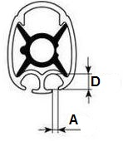

groove opening A = …...............................................
internal diameter D=...................................................
luff tape diameter on existing headsails Ø = ……………………….........................

10 – Spreader patches
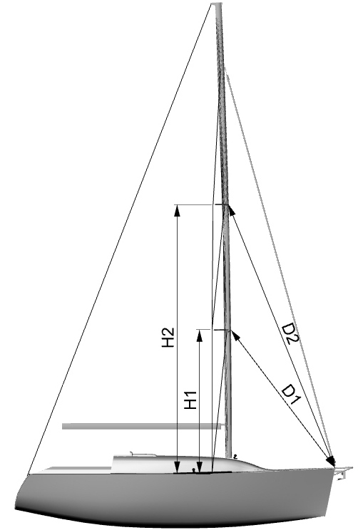
Measure from each spreader's tipto the deck (NOT THE DECKHOUSE!) and then to the forestay base on deck

 | Height above deck | Distance from forestay base
Lower spreader | H1 = | D1 =
Upper spreader | H2 = | D2 =

Notes:

v 1.0

